CRITICAL PRAYER REQUESTS
February 12th, 2021

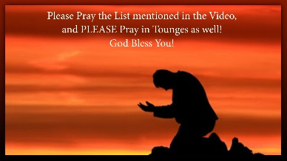
May Dear family of Heart Dwellers, it has come to my attention that the impeachment farce is just another distraction to give the enemy time to institute terrible measures against the American people. So, I am asking you to pray for the following intentions which are incredibly high on the list of priorities.

* Pray that evil will be exposed and disarmed before it does damage.

* Pray that corruption will be discovered, routed out and brought to justice.

* Pray for safe and secure borders, that trespassers or hostile forces will not penetrate into our country, especially in the Northwest, Washington, Minnesota, Maine, the Northeast, New York, Southwest California, Southeast Florida, and that rioting and evil will not get the upper hand in those places as well as Oklahoma City.

* Pray for the safety of our East and West coast against enemy attacks. Pray that any betrayals by any of our armed forces will be discovered and thwarted.

* Pray that the United Nations will not gain control of the International
Space Station and that it will not be weaponized. And I pray especially the Blood of Jesus cover and protect the international space station.

* Pray against a worldwide healthcare chip and attempts to force it that it will fail.

* Pray for Freedom of Speech to be protected with new laws and pray protection for the American people to bear arms.

*Pray for the restitution of the rule of law according to our constitution.

* Pray that God will thwart any manipulation of tectonic plates and the New Madrid fault line.

* Pray against misuse of long-range weapons and protection from attempts to use them against our nation.

*Pray protection over our power grids and attempts to take it down.

* Pray against the use of adverse weather control.

* Pray that people will use wisdom and not be falsely lured into camps.
*And pray that any attempts of the Chinese Communist Party to harm America will fail and continue to be discovered and fail.

I am going to go ahead and put this in the description box too so you have the list that you can refer to in prayer. These are the things that we believe are most on the President’s heart right now, so we are going to post them beneath this video. The Lord bless you; dear Heart Dwellers let us all press into prayer together, shoulder to shoulder, our God is with us. Amen.

